**Defect Report - Buggy Cars**

**Defect 1**

**Summary: Unable to vote and add comments in the Stratos Model Page**

**Browser:** Chrome

**Environment:** [**https://buggy.justtestit.org/**](https://buggy.justtestit.org/)

**Reported By:** Minty

**Severity:** Critical

**Priority:** High

**Steps to Reproduce:**

1. Navigate to Buggy cars Rating Home page in Chrome browser
2. Click Overall Rating link in the Home page
3. Select Lancia Make
4. Click “Stratos” model from Lancia Make summary page
5. Verify Details and Click Vote

**Expected Result:**

* User should be able to view the details of the comments in Make summary page for Stratos
* User should be able to view all the details of Stratos model and able to vote and add comments

**Actual Result:**

User is unable to view the details of the comments in Make summary page for Stratos

User is unable to view all the details of Stratos model

When we click vote, nothing happens.

**Screenshot 1**

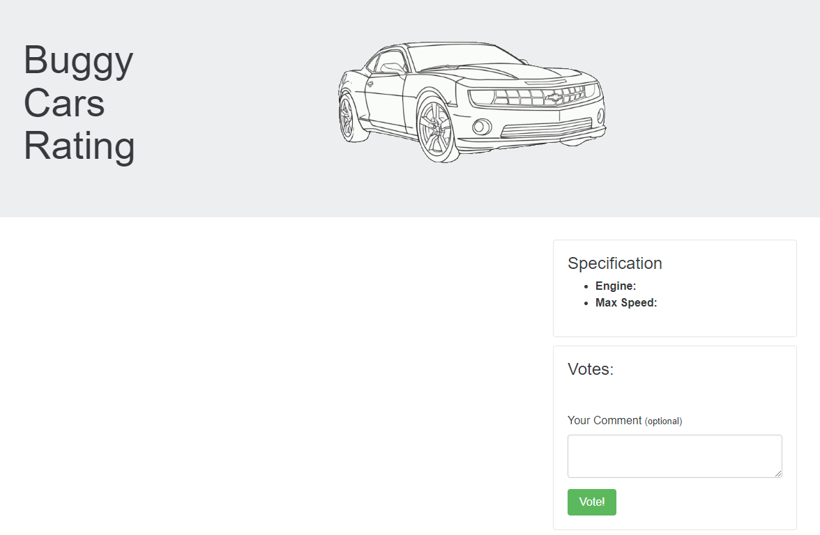

**Screenshot 2**

**Defect 2**

**Summary: Unable to view any models in the Buggy Cars website in Firefox Browser**

**Browser:** Firefox

**Environment:** [**https://buggy.justtestit.org/**](https://buggy.justtestit.org/)

**Reported By:** Minty

**Severity:** Critical

**Priority:** High

**Steps to Reproduce:**

1. Navigate to Buggy cars Rating Home page in firefox browser
2. Click Overall Rating link in the Home page
3. Select the model “Diablo” in the Overall models page
4. Verify user is able to view the details and vote for Diablo model

**Expected Result:** User should be able to view the details and vote for the model.

**Actual Result:** User is unable to view any details of the model and page is keep on loading.

We need to select back and refresh the page to make the application work.

**Screenshot:**

**Defect 3:**

**Summary: User details are displayed in profile page even after user is logged out.**

**Browser:** Chrome

**Environment:** [**https://buggy.justtestit.org/**](https://buggy.justtestit.org/)

**Reported By:** Minty

**Severity:** Critical

**Priority:** High

**Steps to Reproduce:**

1. Navigate to Buggy cars Rating Home page in Chrome browser
2. Login using the valid credentials
3. Click Profile icon
4. Update any user details and save
5. Click logout and verify

**Expected Result:** Page should be refreshed and navigate to home page or any other page.

**Actual Result:** Even after user is logged out, user profile data is displayed.

Screenshot 1:

Screenshot2:

**Defect 4:**

**Summary:** Incorrect Navigation when Clicking on Car Image

**Browser:** Chrome

**Environment:** [**https://buggy.justtestit.org/**](https://buggy.justtestit.org/)

**Reported By:** Minty

**Severity**: Medium

**Priority**: Medium

**Steps to Reproduce:**

1. As a user, navigate to the Overall Rating section.
2. Select any car model.
3. Click on the car logo.
4. Click on the car image.

**Expected Result:** The car image should be zoomed in, allowing the user to view it in detail.

**Actual Result**: Instead of enlarging the car image, the user is unintentionally redirected to the home screen.

**Defect 5:**

**Summary:** Buggy Rating Button and Non-User-Friendly Error Message on Car Make Pages

**Browser:** Chrome

**Environment:** [**https://buggy.justtestit.org/**](https://buggy.justtestit.org/)

**Reported By:** Minty

**Severity**: Medium

**Priority**: Medium

Steps to Reproduce:

1. Login as a registered user on the Buggy Cars Rating page.
2. Click on the "Popular Make" option.
3. Attempt to navigate back to the home page by clicking the "Buggy Rating" button.
4. Observe the unresponsiveness of the button and the non-user-friendly error message.

**Expected Result**: The user should be able to navigate back to the home page by clicking the Buggy Rating button located at the top of the page.

**Actual Result**: The user is unable to navigate back to the home page as the Buggy Rating button does not respond as expected. Instead, a non-user-friendly error message is displayed.

Screenshot:

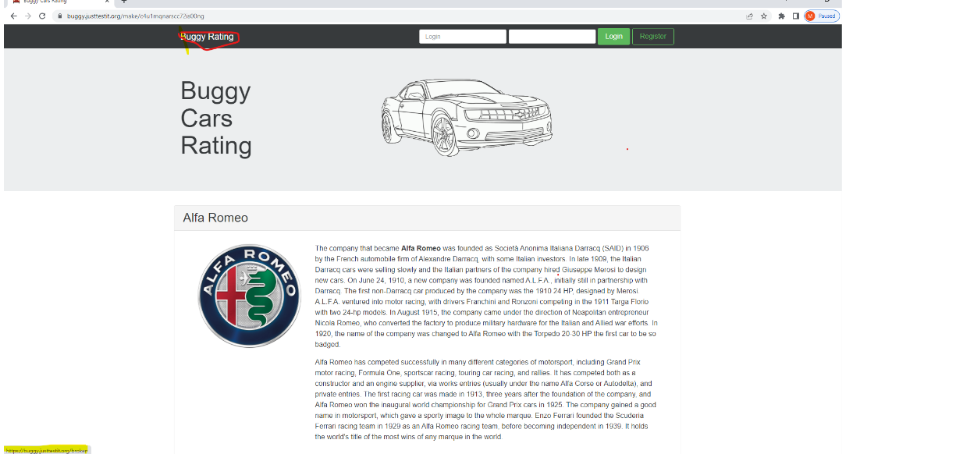

**Defect 6**

**Summary:** Incorrect Page Numbers on Overall Rating Page

**Browser:** Chrome

**Environment:** [**https://buggy.justtestit.org/**](https://buggy.justtestit.org/)

**Reported By:** Minty

**Severity**: Medium

**Priority**: Medium

**Steps to Reproduce:**

1. Go to the "Overall rating" page.
2. Traverse through the pages using the navigation buttons.

**Expected Result**: After reaching the last page (in this scenario, page number 5), the forward button should be disabled, indicating that there are no more pages available.

**Actual Result**: Users can navigate beyond page 5, but no data is displayed on the subsequent page. Additionally, the wording on the page is inconsistent or incorrect.

Severity: Low

Priority: Medium

Screenshot:

